**Aim: Illustration of Hidden Terminal Problem using NS2**

**Theory:**

Hidden Terminal Problem

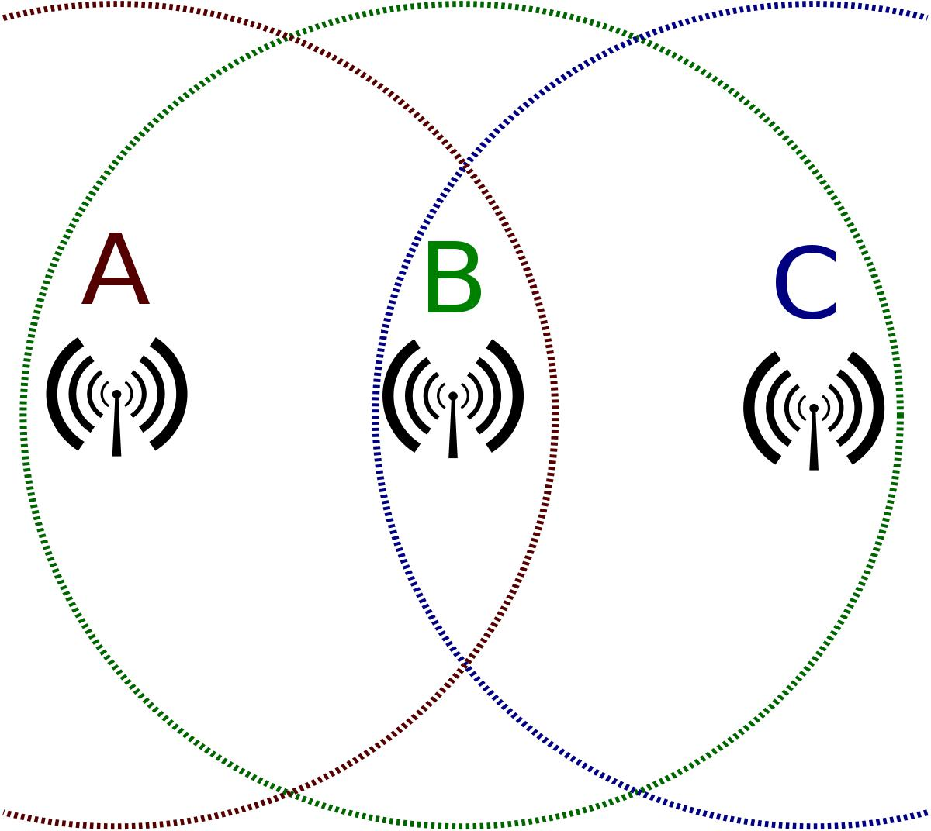

In ​[wireless networking](https://en.wikipedia.org/wiki/Wireless_networking)​, the ​**hidden node problem**​or ​**hidden terminal problem**​occurs when a [node](https://en.wikipedia.org/wiki/Node_(networking))​can communicate with a wireless access point (AP), but cannot directly communicate with other nodes that are communicating with that AP. This leads to difficulties in [​medium access](https://en.wikipedia.org/wiki/Medium_access_control) [control](https://en.wikipedia.org/wiki/Medium_access_control)​sublayer since multiple nodes can send data packets to the AP simultaneously, which creates interference at the AP resulting in neither packet getting through.

Although some loss of packets is normal in wireless networking, and the higher layers will resend them, if one of the nodes is transferring a lot of large packets over a long period, the other node may get very little [​goodput](https://en.wikipedia.org/wiki/Goodput)​.

Practical protocol solutions exist to the hidden node problem. For example, Request To Send/Clear To Send (RTS/CTS) mechanisms where nodes send short packets to request permission of the access point to send longer data packets. Because responses from the AP are seen by all the nodes, the nodes can synchronize their transmissions to not interfere. However, the mechanism introduces latency, and the overhead can often be greater than the cost, particularly for short data packets.

**Simulation using NS2**

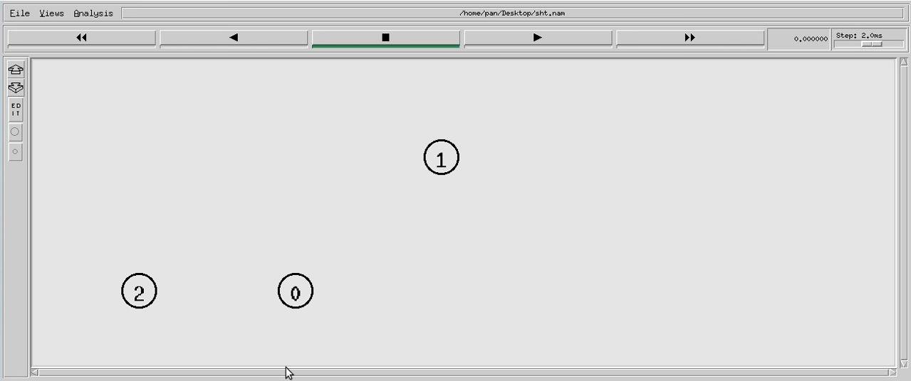

Node 0 and 2 are in range of one another

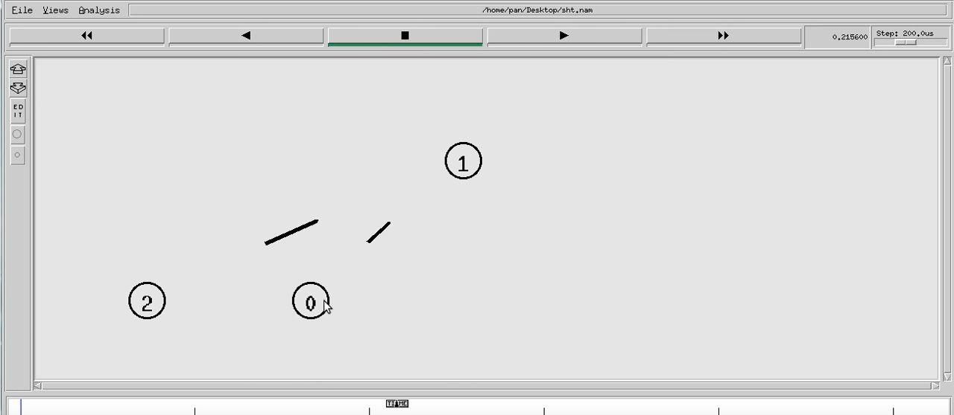

They both sense the carrier channel and send data

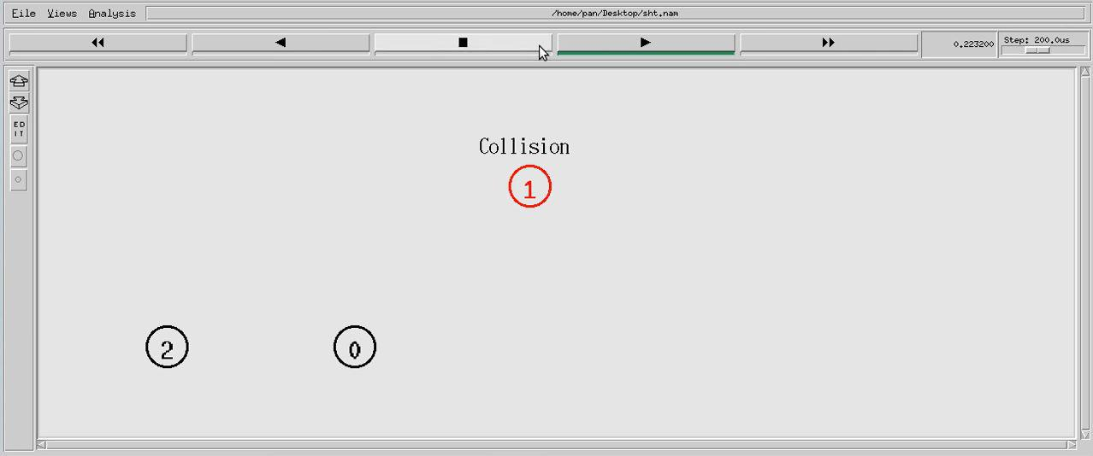

Collision takes place and both nodes will know about it

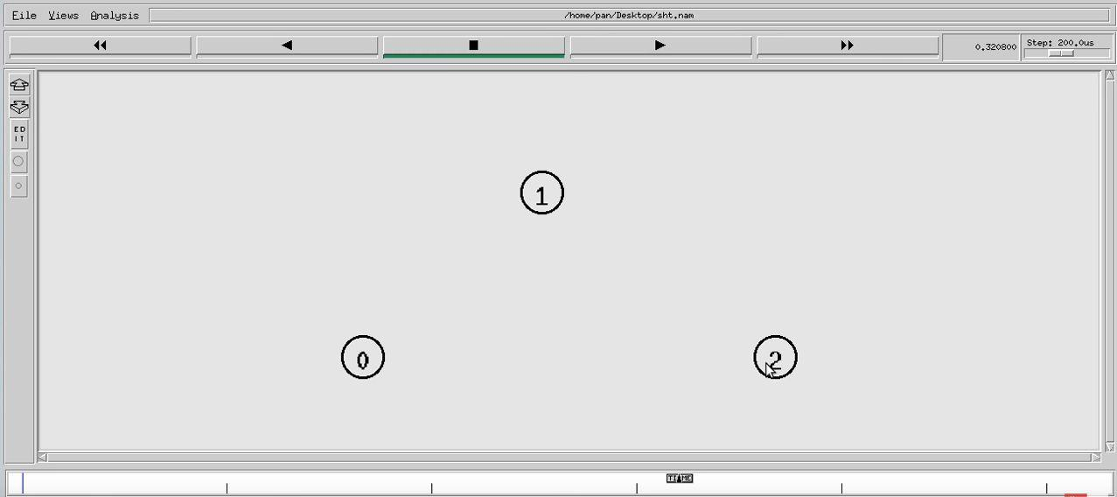

Node 0 and 2 are not in range of one another

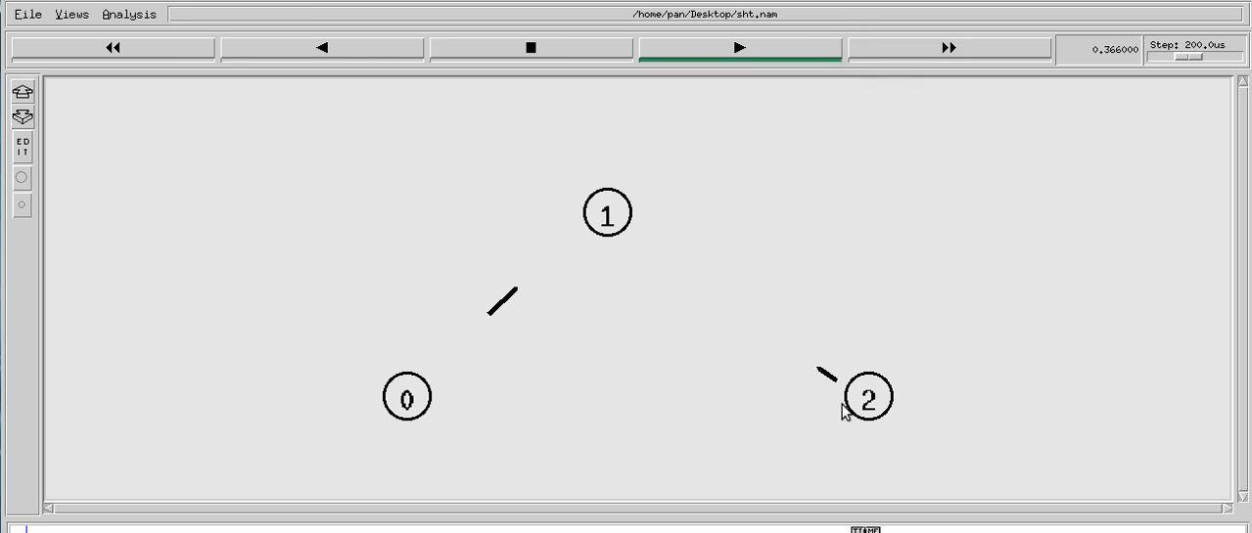

Both sense the carrier channel and start sending data

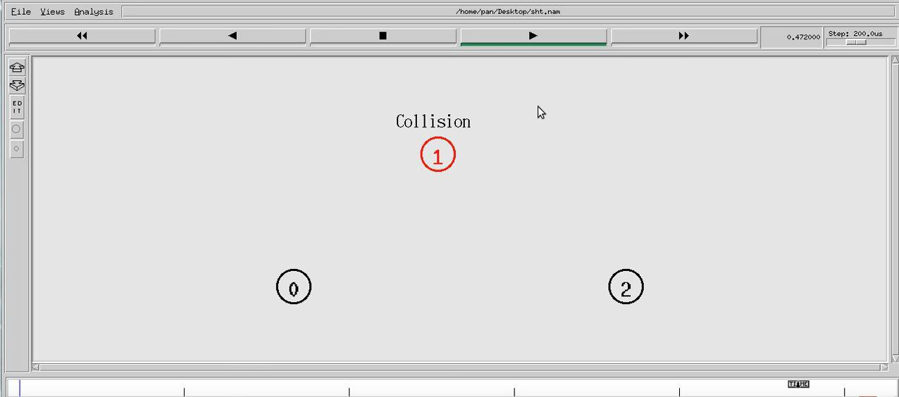

Both wont know about the collision and will keep sending data

**Conclusion:**

In the above experiment, I learnt about the Hidden Terminal problem, and simulated it using NS2.